

**Equal Opportunity Commission**

**Annual Report  
2014 - 2015**

G:\EOC\promotions and publications\layout resources\logos\EOC logos\official logo\eps\eoc_white_trans_horizontal.EPS

**Contents**

[Message from the Commissioner 4](#_Toc392171225)

[Highlights 6](file:///G:\EOC\annual%20planning%20and%20reporting\reporting\EOC%20Annual%20Report\Annual%20Report%2013%20-%2014\Annual%20Report%2013-14%20-%20in%20new%20template.docx#_Toc392171226)

[Complaints and Enquiries 20](file:///G:\EOC\annual%20planning%20and%20reporting\reporting\EOC%20Annual%20Report\Annual%20Report%2013%20-%2014\Annual%20Report%2013-14%20-%20in%20new%20template.docx#_Toc392171227)

[Programs 40](file:///G:\EOC\annual%20planning%20and%20reporting\reporting\EOC%20Annual%20Report\Annual%20Report%2013%20-%2014\Annual%20Report%2013-14%20-%20in%20new%20template.docx#_Toc392171228)

**2014 - 2015**

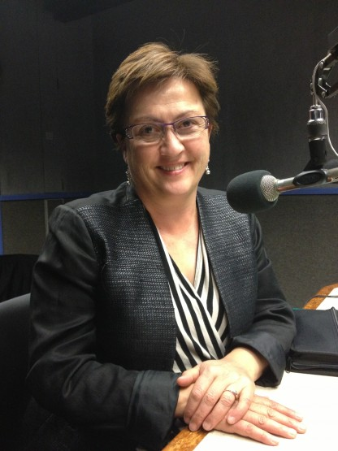Message from the Commissioner

2014 marked the 30th anniversary of the *Equal Opportunity Act 1984* (SA) (the Act). This provided an ideal opportunity to reflect on the legacy of the Act and South Australia’s human rights and equal opportunity achievements.

For the past 30 years, the Act has played an important role in promoting and protecting equality of opportunity for all South Australians. The Act protects our rights, making discrimination in public life unlawful on the basis of a person’s age, race, disability, sex, sexuality and a range of other personal characteristics. The Act also legislated for the creation of the office of the Equal Opportunity Commissioner, providing a dedicated role for promoting equal opportunity and addressing discrimination, sexual harassment and victimisation in the community.

The need for the Act, the office of the Commissioner, and the Equal Opportunity Tribunal has certainly not diminished over the years as we continue to face challenges in achieving a fairer and more equal society.

With the greatest number of complaints continuing to arise from the workplace, this has been a focus area for the Commission this year. In particular, the Commission has worked with the public, private and community sectors to reduce discrimination in recruitment and employment for mature age workers, people with disability, and those who may need flexible working arrangements.

Another priority area for the Commission has been combatting racism. Racism remains the second most common form of discrimination reported to the Commission and we are continuing to implement the National Anti-Racism Strategy in our state.

Gender equity has also been in the spotlight this year, with the National Wage Gap between male and female earnings reaching a record high of 18.8 percent. The gender pay gap in South Australia is significantly lower than the national average at 13.6 percent, but is still deeply concerning. Women also continue to be under-represented in leadership positions.

Violence against women is at epidemic proportions and remains one of the most severe and pervasive forms of gender inequality.

As we move to the future, these examples serve as an apt reminder of the work still to be done in addressing discrimination. Key Commission projects in 2014-15 include:

* The Greatest Asset project to maximise employment opportunities for mature age workers in South Australia.
* The Employment of People with Disability project to ensure the South Australian Public Sector is an exemplar employer of people with disability.
* The Flexible Workplace Futures project to improve the provision and consistency of flexible work practices.
* Roundtables with peak multicultural and Aboriginal bodies to identify priority areas for addressing racism.
* SA Public Sector White Ribbon Workplace Accreditation Project to reduce violence against women and promote gender equality.
* Chiefs for Gender Equity group - male business leaders addressing gender inequality in their own businesses and industries in South Australia.

This work has been complemented by our various community education, training and conciliation services.

A key highlight for the year was seeing our Facebook and Twitter audience grow by more than 150 per cent. This strong social media presence provides new opportunities to educate the community about their rights and responsibilities under equal opportunity law.

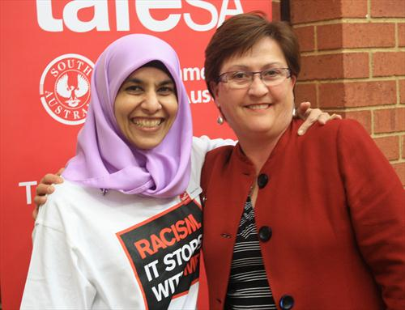

*Commissioner Anne Gale with TAFE SA Acting Chief Executive Officer, Miriam Silva at the TAFE SA sign up to the National Anti-racism Campaign*

I thank the Commission staff for their continued commitment and hard work during this past year and all our government, business and community partners for their support.

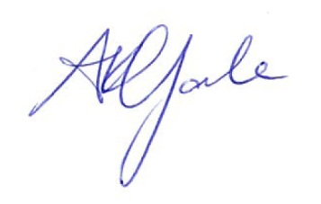

**ANNE GALE**

***Commissioner for Equal Opportunity***

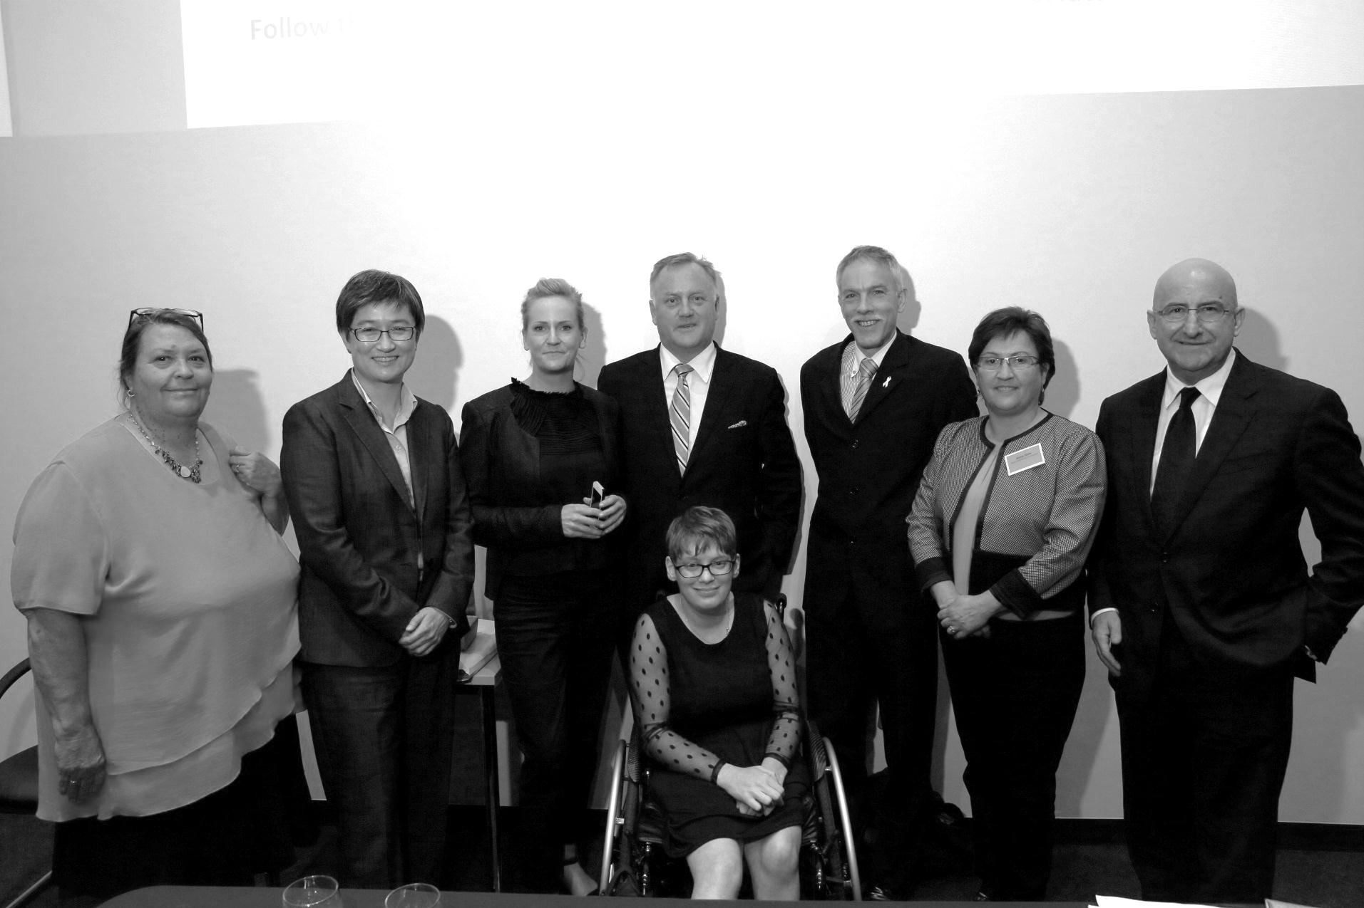

The Commissioner and the Community 7

SA Public Sector White Ribbon Workplace Accreditation 9

30th Anniversary of the Equal Opportunity Act 11

Timeline of Equal Opportunity in SA 13

Employment of People with Disability project 14

Flexible Workplace Futures 15

Policy responses 16

Highlights

The Commissioner and the Community

**Highlights**

The Commissioner is asked to speak at many events during the year. This year, the Commissioner was invited to speak at, or participate in, a number of forums and events on topics which included disability, diversity in the workplace, the mature workforce, human rights, gender bias, and anti-racism.

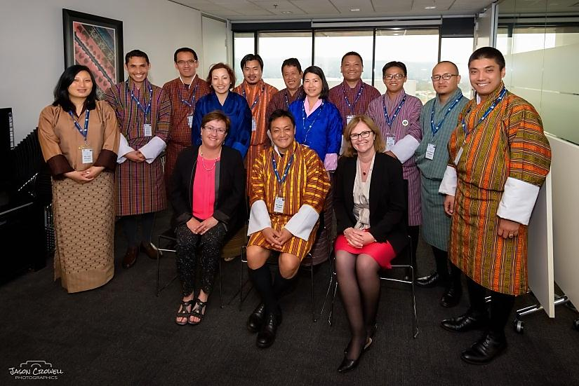

*Commissioner Anne Gale with representatives from the Bhutan Government and Industry Development Group and Julie Sloan, Chief Executive Workforce Planning Global   
[Photo: Jason Crowell Photographics]*

The Commissioner’s engagements during 2014-15 included:

* Panellist for the Office for the Ageing’s *‘Investing in Experience/The benefits of Experience: a Mature Workforce’* forum
* *‘Discrimination in the workplace’* presentation for SafeWork Week 2014
* Gender equality presentation at the Industrial Relations Society of SA State Convention
* Presentation at the *‘Reframing Ageing: The positive economics of ageing & aged care’* forum hosted by the Committee for Economic Development of Australia
* Guest speaker at the SA State School Leaders Association Seminar

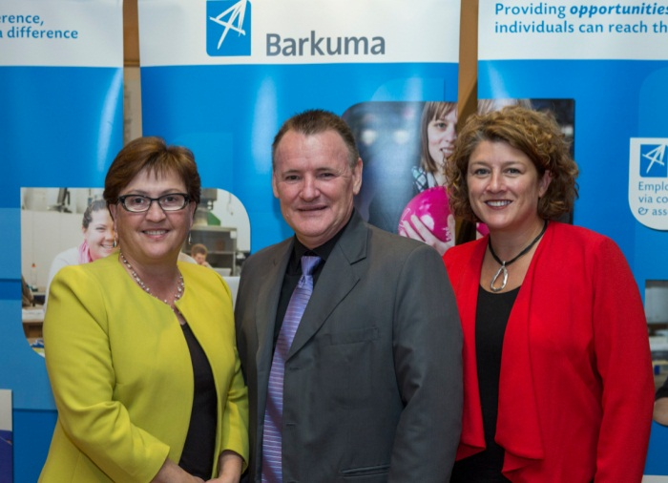

*Commissioner Anne Gale, Geoff Blackwood and Jo Stagg at the Barkuma Business Breakfast*

* Presentation to the Australian Human Resources Institute Diversity Network about the SA Chiefs for Gender Equity
* Presentation to Programmed Property Services as part of International Day of People with Disability celebrations
* Panellist and presenter at *‘The research, the requirements, and the reality: Gender diversity within the mining and resources industry’* event at the University of South Australia

* Presentation to the Bhutan Government and Industry Development Group
* MC for the Women's Lawyers Association forum
* Presentation at the Barkuma Business Breakfast on persons with disability and employment

* Speaker at TAFE SA’s signing of the National Anti-Racism campaign agreement

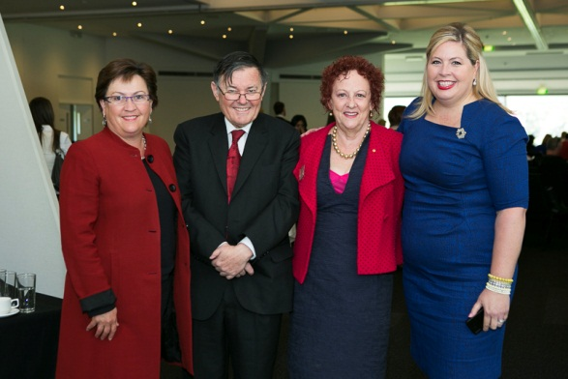

*Commissioner Anne Gale, Dr David Caudrey (Executive Director, Disability SA), Rosemary Warmington (CEO, Carers SA) and Katrine Hildyard MP at the SA Carers Awards*

* Presentation at a Legalwise seminar aimed at countering gender bias in the legal profession
* Regular presentations to businesses at the Office of the Small Business Commissioner’s BizLinks sessions
* Judge for the South Australian Carers Awards
* Launched the *Sport for Rural Health* program, a joint initiative by UniSA’s Division of Health Sciences and the Department of Rural Health, in Whyalla

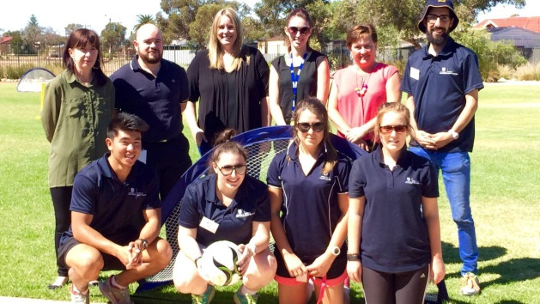

*Commissioner Anne Gale at the Sport for Rural Health program launch in Whyalla*

SA Public Sector   
White Ribbon   
Workplace Accreditation

**Highlights**

In 2014, South Australian Premier, the Hon Jay Weatherill pledged that domestic violence would be a priority for his Government and launched *‘Taking a Stand: responding to domestic violence’*. As part of this initiative, the Premier committed the South Australian public sector, the largest employer in the State, to lead a broader policy response in addressing violence against women.

Coordinated by the Equal Opportunity Commission, the SA Public Sector White Ribbon Workplace Accreditation Project is a male led primary prevention initiative that recognises the positive role that men play in preventing violence against women.

The purpose of the project is to assist State Government departments in recognising the negative impacts violence has on the health and safety of women at work, as well as their wellbeing and productivity.

The project supports workplaces to adapt organisational culture, practices and procedures so that they promote safe workplaces for women and respectful relationships between all workers. With over 100,000 employees, the South Australian public sector has the potential to significantly contribute to the cultural shift required to reduce violence against women and promote gender equality.

The primary reasons for undertaking this project are:

* One in five women experience harassment in the workplace [[1]](#footnote-1);
* Over 12 months, on average, one woman is killed in Australia every week by a current or former partner [[2]](#footnote-2);
* Violence against women is estimated to cost $14.4 billion to the Australian economy per annum [[3]](#footnote-3);
* Violence not only impacts on the health, safety and productivity of women at work, but also has a negative impact on the reputation of workplaces.

By participating, it is anticipated that departments will benefit by:

* Improving the support offered to employees who are victims of violence;
* Increasing staff knowledge about the issue of violence against women and, in doing so, change attitudes and behaviours, helping to prevent violence in the workplace;
* Improving their reputation in professional networks and the wider community, thereby increasing public confidence.

Benefits also include:

* Improved overall safety, morale and retention of employees;
* Improved work productivity and reduced absenteeism;
* Mitigation of risk in terms of anti-bullying legislation.

The Project runs from February 2015 to July 2016.

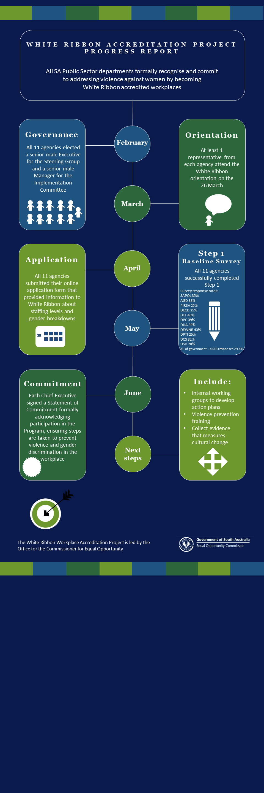

30th Anniversary of the Equal Opportunity Act

**Highlights**

The *Equal Opportunity Act 1984* (SA) has played an important role in promoting equality of opportunity for all South Australians. The Act makes discrimination unlawful in public life if based on a person’s age, race, disability, sex, sexuality and a range of other personal characteristics.

To mark the 30 year anniversary of the Act, the Equal Opportunity Commission in association with The Bob Hawke Prime Ministerial Centre, held a Great Debate on Human Rights Day, 10 December 2014.

The topic *“30 years on, do all South Australians really have a fair go?”* was vigorously and entertainingly debated by:

* Senator the Hon. Penny Wong
* Hon Kelly Vincent MLC
* Commissioner for Victims’ Rights Michael O'Connell
* Judge Rauf Soulio
* Professor Irene Watson
* Tory Shepherd, Political Editor

Debate moderator was barrister Alex Ward.

To watch the video or listen to the podcast of the Great Debate, visit: [www.eoc.sa.gov.au/eo-resources/events/  
other-events/great-debate](http://www.eoc.sa.gov.au/eo-resources/).



To commemorate the anniversary, the Commission also developed an interactive online timeline of Equal Opportunity in South Australia (see the following story), which was launched at the debate by the Minister for the Status of Women, the Hon Gail Gago.

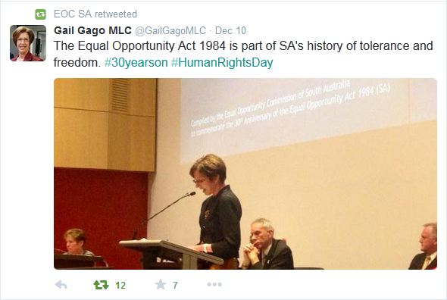

Attendees included previous Equal Opportunity Commissioners Anne Burgess and Linda Matthews, pictured below with Commissioner Anne Gale.



As part of the Equal Opportunity Act’s 30th year, the Commission also held a series of Lunch and Learn sessions. The three free sessions were a great success and gave people the opportunity to hear from a number of inspiring South Australians.

Our guest speakers were Adelaide barrister Heather Stokes, paralympians Katrina Webb and Grace Bowman, and Mohammed Al-Khafaji, who came to South Australia as an Iraqi refugee and is now CEO of *Welcome to Australia*. Each of our wonderful speakers shared their personal stories and insights and took questions from the audience.

Audience feedback included:

“*For me, the session provoked thought and many positive conversations subsequently amongst my friends and colleagues*”.

“*I found the talk really interesting. We have had a couple of employees in our organisation transition and it was beneficial to see how Heather approached the challenge of letting the workplace know*”.

“*It was so interesting to hear Grace and Katrina's stories and to be able to ask questions. Both were very engaging and their openness was very much valued and appreciated*”.

“*I am studying Community Development and hearing Mohammad speak gave me insight to how a new arrival’s settlement was*”.

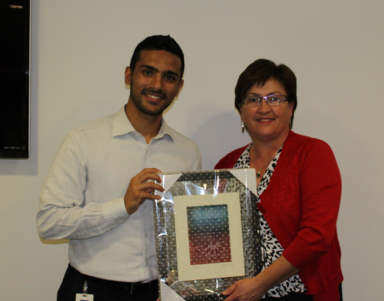

*Commissioner Anne Gale with Mohammed Al-Khafaji*

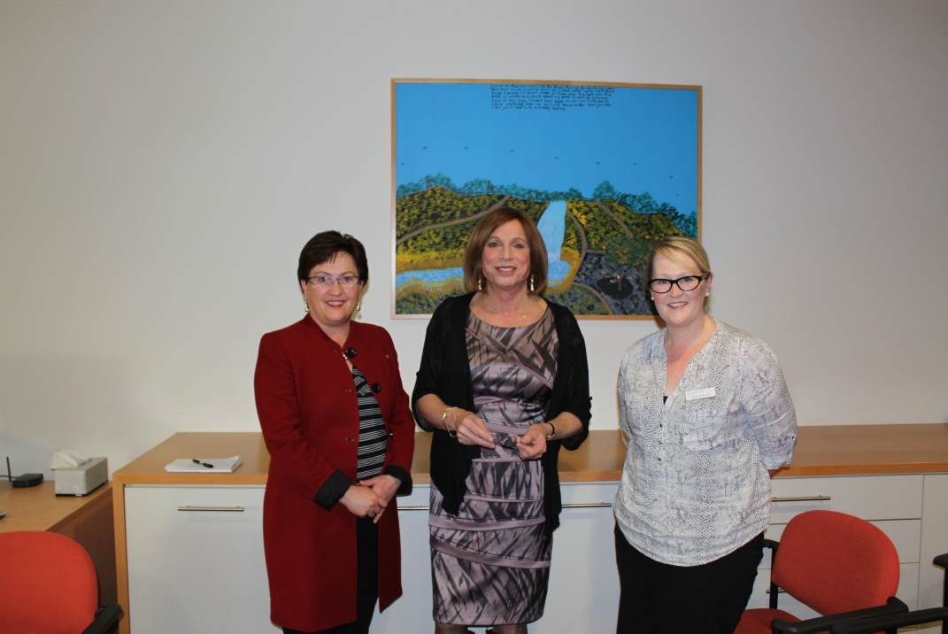

*Commissioner Anne Gale with Heather Stokes and Cecilia White*

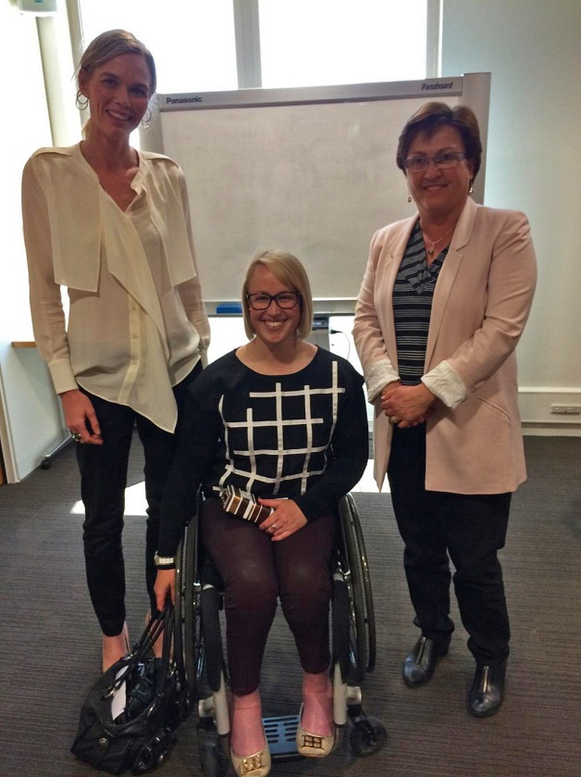

*Katrina Webb and Grace Bowman   
with Commissioner Anne Gale*

Timeline of Equal Opportunity in SA

**Highlights**

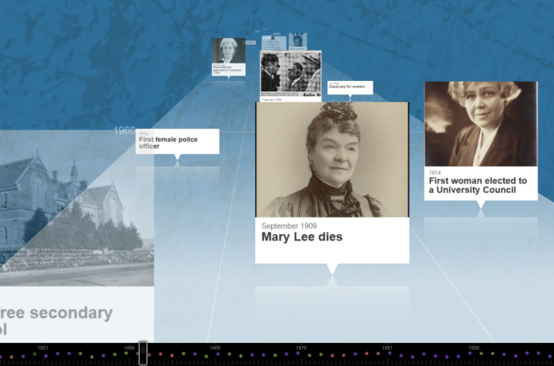To mark the 30th anniversary of the *Equal Opportunity Act 1984* (SA), the Equal Opportunity Commission compiled a timeline of significant milestones and key events in South Australia’s history which have improved equality of opportunity and human rights for South Australians.

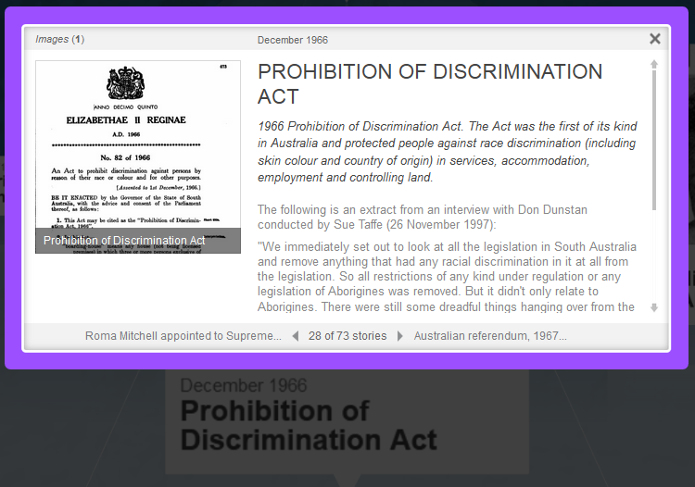The timeline documents South Australia’s history as an early leader in human rights and includes major legislative milestones including the introduction of the Equal Opportunity Act and subsequent amendments.

The timeline provides a valuable source of information for students and anyone who is interested in the history of human rights in our state. The Commission will continue to update the timeline and is happy for people to provide feedback and suggestions for inclusions via our website or by phone.

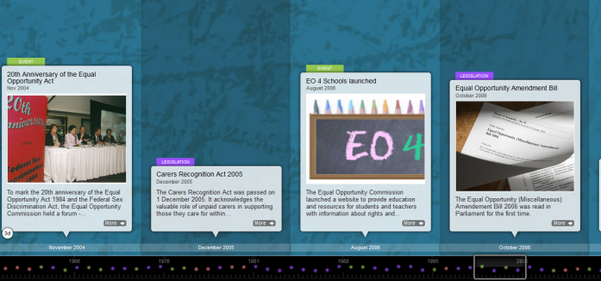Read more and find a link to the timeline at: [www.eoc.sa.gov.au/eo-resources/timeline-eo-sa](http://www.eoc.sa.gov.au/eo-resources/timeline-eo-sa).

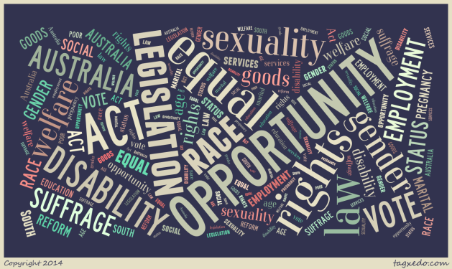

Employment of People with Disability Project

**Highlights**

In July 2014, the Commissioner for Equal Opportunity commenced an across government 90 day project, *(Public Sector) Employment of People with Disability*. The project aimed to contribute to the [South Australia Strategic Plan Target 50](http://saplan.org.au/targets/50-people-with-disability) to increase the number of people with disability employed in South Australia and to ensure that the South Australian public sector is an exemplar employer of people with disability.

The project objectives were to:

1. Increase the number of people with intellectual disability employed in the public sector.
2. Identify a consistent and contemporary online disability awareness tool and mechanism for hosting the tool.
3. Create a central site of useful tools and resources for employers and employees, including good practice examples.

The project achieved significant outcomes, including:

* Supporting the successful employment of eight persons with an intellectual disability in the public sector.
* Publishing an *Employment of People with Disability Reference Guide* on the Equal Opportunity Commission website at: [www.eoc.sa.gov.au/eo-resources/  
  employment-people-disability](http://www.eoc.sa.gov.au/eo-resources/employment-people-disability). The guide provides links to information and support available for employers and employees during both recruitment and employment. A good practice fact sheet is also included.
* Progressing the design and development of an online disability awareness tool for the public sector.

Project members include the Equal Opportunity Commission as lead agency, the Department for Communities and Social Inclusion, Office for the Public Sector, the Department of Primary Industries and Regions SA, the Department of State Development, and Barkuma’s Personnel Employment service. The project team continue to meet to drive cultural change in support of employment of people with disability in the public sector and to facilitate the disability awareness training tool.

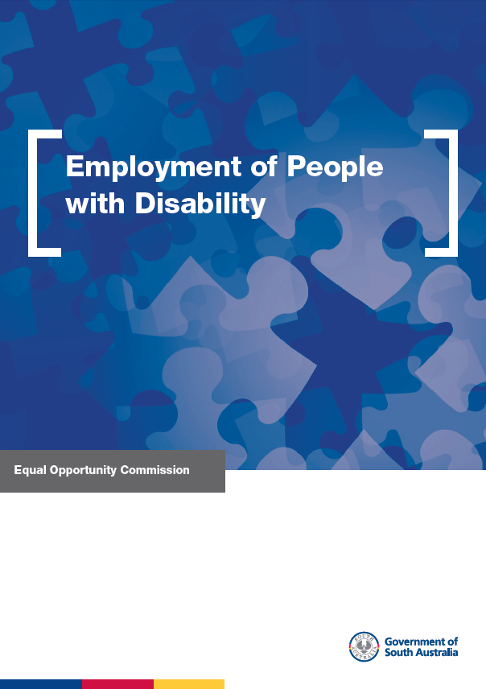

*Employment of People with Disability:   
Good Practice Guide cover*

Flexible Workplace Futures

**Highlights**

The Flexible Workplace Futures project is a longer term, across government project approved under the Public Sector Renewal Program. The project aims to create a more productive, dynamic and flexible workforce which is able to adapt to the future needs of the State Government and the community.

The Equal Opportunity Commission has worked with a wide range of state government agencies on the project to achieve a number of goals including:

* A new Commissioner for Public Sector Employment Guideline and Determination on Flexible Workplaces.
* Research on flexible work and sourcing best practice.
* An online information package for use by government agencies and the private sector. This package was downloaded 9,788 times in 2014-15 and is available at: [www.eoc.sa.gov.au/eo-resources/flexible-workplace-futures](http://www.eoc.sa.gov.au/eo-resources/flexible-workplace-futures).
* Tools for managers and staff including application forms, a table of possible actions, case studies, check lists, and a staff survey.
* Supporting agencies to implement flexible work policies and practices.

Following the initial project, the Equal Opportunity Commissioner addressed the Public Sector Senior Management Council on achievements and made recommendations for future action.

Future steps will include a forum on flexible work aimed at public sector managers and staff - *Working outside the square: flexibility, innovation and technology* - hosted by the Equal Opportunity Commission in partnership with the Office for the Public Sector and the Institute of Public Administration Australia.

A core group of the initial project team continues to work on examining technology as an enabler of flexibility, activity based working, flexible work and rosters, and exploring best practice.

The Higher Performing Workplace Index survey was also rerun in mid-2015. Survey data will build on existing data obtained through the same survey in 2013.

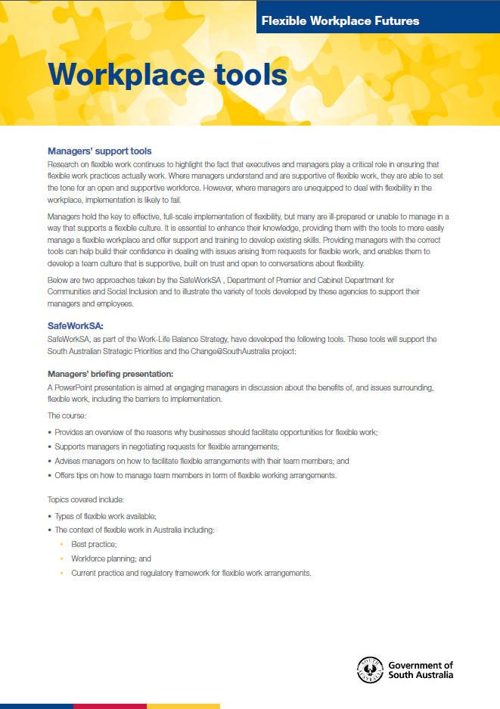

*Page from the Flexible Workplace Futures Package*

Policy Responses

**Highlights**

The Commission lodged the following policy submissions in 2014-15:

### *Working longer - Work Health and Safety and Workers Compensation issues*

(September 2014)

In its submission, the Commission raised a number of issues that can impact on meaningful participation in the workforce for older South Australians. These included insurance issues for people who are self-employed, superannuation, availability of flexible working arrangements, perceptions of mature age workers as being at a higher risk of workplace injury and illness, and stereotyping. The Commission suggested that workforce planning which supports career transitions, along with modernised flexible and adaptable insurance, income protection, and workers compensation schemes that design products around skills and capacity rather than age, will assist people to work longer and more equitably.

### *Criminal Law Consolidation (Provocation) Amendment Bill 2013 / Inquiry into the Partial Defence of Provocation*

### (July 2014; May 2015)

The Commission made a submission to the 2014 Inquiry into the *Criminal Law Consolidation (Provocation) Amendment Bill 2013* and also to the 2015 inquiry which stemmed from the *Report of the Legislative Review Committee into the Partial Defence of Provocation.* The 2015 inquiry followed the High Court Decision of *Lindsay v The Queen* [2015] which set aside the decision of the South Australian Court of the Criminal Appeal *R v Lindsay* [2014] SASCFC 56.

In light of *Lindsay v The Queen*, the Commission took the position that a change of the law may be necessary to prevent future use of the defence of provocation on the basis of a non-violent homosexual advance. However, the Commission concurred with the point made in the Law Society of South Australia’s submission to the Amendment Bill, that it may be discriminatory to only exclude homosexual advances, rather than any unwanted sexual advances. The Commission therefore supported a broader review of the law of provocation, to ensure the ‘gay panic’ defence is removed in the most equitable manner possible.

### *Review of Boxing and Martial Arts Legislation*

(January 2015)

The Commission provided comment to the Office for Recreation and Sport on selected recommendations made regarding the legislation governing competitors in boxing and martial arts in South Australia. The Commission’s comments related to pregnancy and transgender competitors.

Enforcing a ban on pregnant women competing in events to reduce or avoid liability could amount to unlawful discrimination. The Commission submitted that it is in support of organisations providing appropriate advice and information so that pregnant women, in consultation with their medical practitioner, can make their own informed decision concerning their participation.

In relation to same sex bouts, the Commission argued that proposed amendments to boxing and martial arts legislation requiring each contestant seeking registration to produce a birth certificate indicating their gender, or a Recognition Certificate, could amount to unlawful discrimination on the ground of chosen gender.

While the Commission noted that individuals have a right to compete in a fair competition which aligns with their strength, stamina and physique, the Commission argued every reasonable effort should be made to facilitate fair participation in sporting competitions of the gender that a person identifies with.

### *Review of the South Australian Adoption Act 1988 and Adoption Regulations 2004*

(January 2015)

In this submission, the Commissioner supported any legislative changes that would see prospective parents assessed on their fitness, ability and commitment to provide the care and nurture required by each particular child. The Commission‘s view is that a person’s sexuality or marital status does not have any bearing on their parenting capability.

### *Sexual Orientation Gender Identity & Intersex Rights (SOGII)*

(February 2015)

This submission to the Australian Human Rights Commission focused on issues related to SOGII rights in South Australia. Areas highlighted included terminology used in the *Equal Opportunity Act 1984* (SA), SOGII rights issues at school, participation of transgender people in sport, and adoption. The Commission supported initiatives that can help to break down the barriers that still exist for LGBTIQ individuals, including training, education, and support services. The Commission also noted that the existence of legislative barriers sends a message of social inequality that will be hard to overcome until these barriers are removed.

### *Sexual Reassignment Repeal Bill 2014*

(April 2015)

The Commission’s submission to the Legislative Review Committee’s consultation supported the proposed repeal of the *Sexual Reassignment Act 1988*. The Commission noted that the restriction of gender recognition to individuals who have undergone reassignment surgery creates insurmountable hurdles for many transgender people who, in every other way, live as their identified gender. This can create issues with employers, education providers, financial institutions, and service providers.

The Commission also supported adding a ‘non-specific’ gender option for the South Australian Registrar of Births, Deaths and Marriages when registering births. This would provide an appropriate option for individuals who do not identify as male or female and, in addition, provide a necessary incentive for organisations to provide gender neutral (or no) titles in their records.

### *NDIS National Quality and Safeguards Framework*

(April 2015)

The Commission supported the need for a Quality and Safeguarding Framework for the NDIS, noting that relying on market forces to ensure quality will be insufficient. The Commission noted that this is even more relevant where there is limited choice of service provider for participants, such as in regional and remote areas, and for limited, specialised services.

The Commission noted that both participants and providers will require access to information and resources to ensure good outcomes, and that suitable complaint systems must be available. The provision of appropriate risk management mechanisms is particularly important for small providers and for regional and remote services. While it is always desirable to minimise red tape and bureaucracy, vulnerable people must not be put at risk of poor quality services, exploitation or abuse whilst a service system evolves.

### *Aboriginal and Torres Strait Islander experience of law enforcement and justice services*

(April 2015)

The Commission noted that it receives only a small number of complaints and enquiries from Aboriginal and Torres Strait Islander (ATSI) people, and that many of them do not have legal assistance or representation.

Information received from the Aboriginal Legal Rights Movement confirms that ATSI people continue to face discrimination on a regular basis. The Commission acknowledged that only a small percentage of ATSI people experiencing discrimination will report it to the Commission.

In the submission, the Commission noted its support for initiatives such as early intervention and ‘justice targets’ which can improve reporting and outcomes for ATSI people across the justice system.

### *Review of the Disability (Access to Premises – Building) Standards 2010*

(June 2015)

As part of the *Premises Standards* Review process, the Commission provided data on disability discrimination complaints and enquiries that it had received in relation to ‘access to premises’, plus several case studies, to the Commonwealth Attorney-General's Department. It also made a submission to the Premises Standards Review Team.

Issues highlighted by the Commission include businesses’ lack of knowledge regarding their obligations in relation to accessibility; that compliance with the Standards alone may not achieve accessibility due to other building or venue features; that triggers for the Standards are limited; and a lack of monitoring of compliance. The Commission also noted the inadequacy of relying on complaints to human rights and equal opportunity agencies as a mechanism for monitoring compliance with the Premises Standards. This is due to the fact that, under legislation, complaints can only be accepted from individuals with a disability who have suffered a detriment.

### G:\EOC\promotions and publications\photos\stock photos\iStock Photos\iStock 3554922 Law and fountain pen - 2.jpg*2015 Review of the Disability Standards for Education 2005*

(June 2015)

The Disability Standards for Education were formulated by the Commonwealth Attorney-General under the *Disability Discrimination Act 1992* (Cth) with the purpose of providing a framework to ensure that students with disability are able to access and participate in education on the same basis as other students. The Standards aim to do this by providing clarity and specificity for both education and training providers, and for students with disability. The Minister for Education and Training, in consultation with the Attorney-General, is required to conduct a review of the effectiveness of the Standards every five years.

This submission drew on the Equal Opportunity Commission’s experience with the Standards through assessment and conciliation of disability discrimination complaints in the area of education. The Commission suggested that clarification of terminology and provision of examples/guidelines could assist in providing more consistent and successful application of the Standards. It also suggested a more ‘user-friendly’ version would increase the ability of families to reference the Standards.

The Commission raised other issues such as lack of inclusion of work study placements and the difficulty of balancing the needs of students with violent behavioural problems with the safety of staff and other students. It also suggested the addition of a monitoring and evaluation tool to help evaluate and improve the Standards on an ongoing basis.



Complaints and Enquiries

Enquiries 21

Complaints Received 23

Whistleblowers 27

Complaint Outcomes 28

Our Service 30

The Equal Opportunity Tribunal 32

Complaints Referred to the Tribunal 34

Tribunal Decisions in 2014-15 37

Other Tribunal Matters Finalised in 2014-15 39

Enquiries

**Complaints**

The Commission receives telephone and email/website enquiries from individuals who believe they have experienced discrimination. Enquiries are also received from businesses, community organisations and equal opportunity contact persons seeking information about discrimination issues and equal opportunity. The Commission’s enquiry service is free and enquiries can be made anonymously.

An enquiry is often a first step prior to a formal complaint being lodged in writing. It is a useful opportunity for information to be exchanged and options to be explored.

In 2014-15, the Commission received 1,196 enquiries, down 15% from 2013-14. Enquiry numbers have steadily declined over the past decade as more people visit our websites to find information and resources (see page 49).

The graph below shows the types of discrimination people enquired about this year. Almost 12% of enquiries received related to issues that the Commission could not assist with, as they did not fall within the *Equal Opportunity Act 1984* (SA). When issues fall outside of the Act, enquiry officers will generally refer enquirers to other complaint organisations, advocates or legal advice for assistance.

**Enquiries 2014-15 - types of discrimination (grounds)**

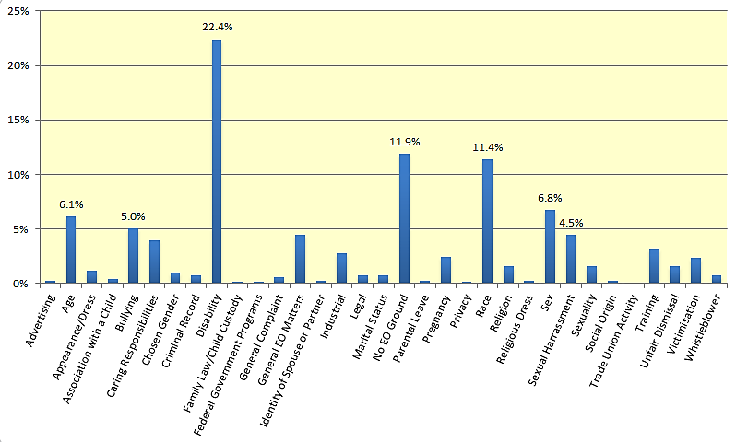

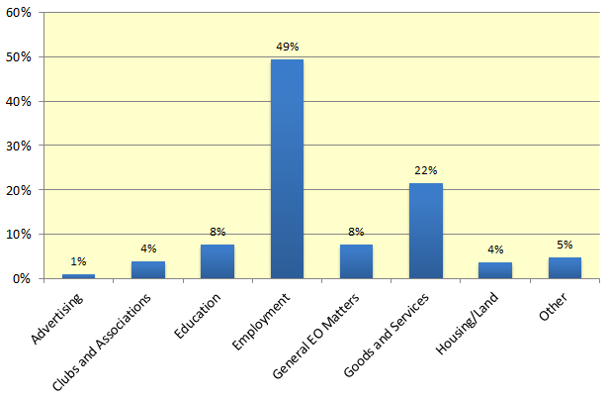**Enquiries 2014-15 - places of discrimination (areas)**

**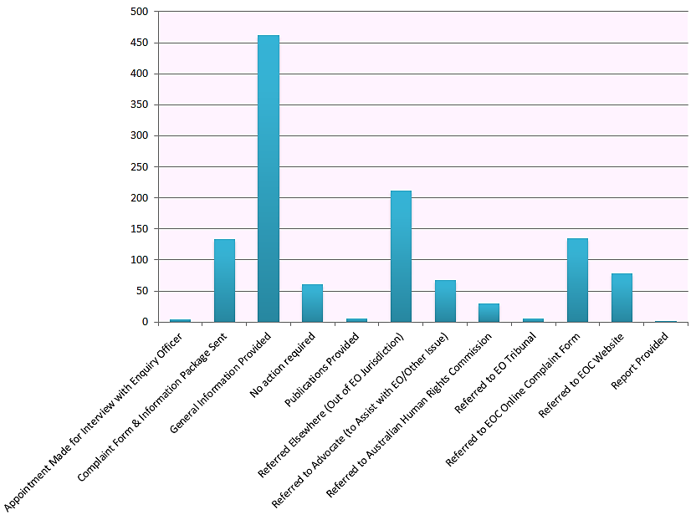**  
**Enquiries 2014-15 - outcomes**

Complaints Received

**Complaints**

People can make a complaint to the Commission if they believe they have been discriminated against. Complainants need to demonstrate that the reason for the discrimination was one (or more) of the grounds listed in the *Equal Opportunity Act 1984* (SA), including age, race, sex and disability. The discrimination must also have happened in an area of public life, such as employment or goods and services.

In 2014-15, 217\* complaints were received - up 8% on complaints received in 2013-14. In 2014-15, 172 complaints were finalised. This year, 57% of complaints were lodged by males, 42% by females and 1% by persons who are transgender.

As with previous years, the most common ground of discrimination was disability. This year, 35% of all complaints alleged disability discrimination.

Race discrimination was again the second most common form of discrimination reported (17% of complaints). Victimisation was a close third, with 16% of complainants including allegations of victimisation (up from 7.5% in 2013-14). Victimisation is treating people unfairly for complaining, or helping others to complain, about discrimination or harassment.

Some complaints included more than one ground of discrimination and the total number of grounds was 271. Of these, disability and race discrimination accounted for 28% and 13% respectively.

Half of the complaints received in 2014-15 related to discrimination in employment. This is a reduction from 2013-14, when 58% of complaints lodged were employment related. Employment includes treatment during recruitment or at work, and termination of employment. As a percentage of complaints, education complaints were up 4% to 11% and there were 2% increases in both housing complaints (to 4%) and complaints about clubs and associations (to 6%).

Some types of discrimination, such as religion, political opinion, criminal record and trade union activity are only dealt with by Federal law. Other types of discrimination are covered by both South Australian and Federal law. Where discrimination is covered by State and Federal law, complaints may be lodged with either the state or federal body, but not with both.

If a complaint is lodged that falls outside of the Equal Opportunity Act, the Commission will refer the complainant to other organisations which may be able to assist, including the Australian Human Rights Commission.

If an individual witnesses discrimination, or does not wish to lodge a complaint, they can complete an Online Incident Report on the Commission’s website. Members of the public can report an incident of discrimination they were affected by, either as a witness or victim, and have the option to remain anonymous. The Incident Report is not a formal complaint but can help the Equal Opportunity Commission to better understand issues people are experiencing in South Australia, as well as help identify strategies to prevent them.

*[\* Note that the number of complaints and percentages of grounds and areas of discrimination may be subject to slight variation as some complaints received in 2014-15 are still in the assessment phase and grounds and respondents may still be added.]*

### Grounds and Areas of complaints lodged in 2014-15

|  |  |  |  |  |  |  |
| --- | --- | --- | --- | --- | --- | --- |
|  | **Employment** | **Goods and Services** | **Education** | **Clubs** | **Housing** | **Total** |
| Disability | 31 | 30 | 11 | 7 | 3 | 82 |
| Race | 18 | 12 | 3 | 2 | 2 | 37 |
| Victimisation | 26 | 3 | 2 | 3 | 2 | 36 |
| Age | 18 | 3 | 3 | 1 | 1 | 26 |
| Sex | 11 | 8 | 0 | 1 | 3 | 23 |
| Sexual Harassment | 19 | 0 | 2 | 0 | 0 | 21 |
| Whistleblower | 11 | 1 | 0 | 1 | 0 | 13 |
| Marital Status | 6 | 2 | 2 | 0 | 2 | 12 |
| Caring Responsibilities | 3 | 4 | 1 | 0 | 1 | 9 |
| Sexuality | 3 | 4 | 0 | 0 | 0 | 7 |
| Pregnancy | 6 | 0 | 0 | 0 | 0 | 6 |
| Identity of Spouse or Partner | 2 | 2 | 0 | 0 | 0 | 4 |
| Association with a Child | 0 | 2 | 1 | 0 | 1 | 4 |
| Aiding Unlawful Act | 3 | 0 | 0 | 0 | 0 | 3 |
| Chosen Gender | 0 | 2 | 0 | 0 | 0 | 2 |
| Religious Dress | 0 | 0 | 0 | 0 | 0 | 0 |
| **Grand Total** | **157** | **73** | **25** | **15** | **15** | **285\*** |

*\*Although there were 217 complaints lodged, some complaints of discrimination are lodged under more than one area or allege more than one ground of discrimination.*

**Complaints lodged 2014-15: Types of discrimination**

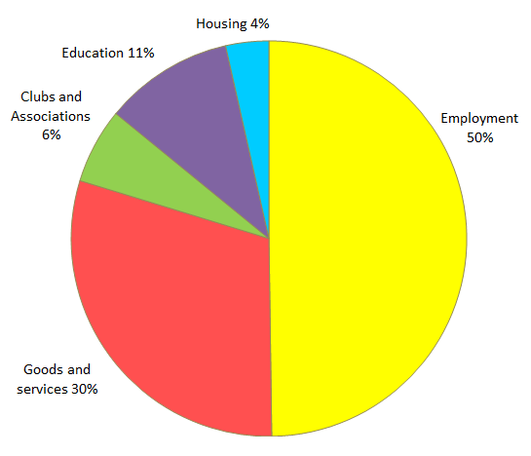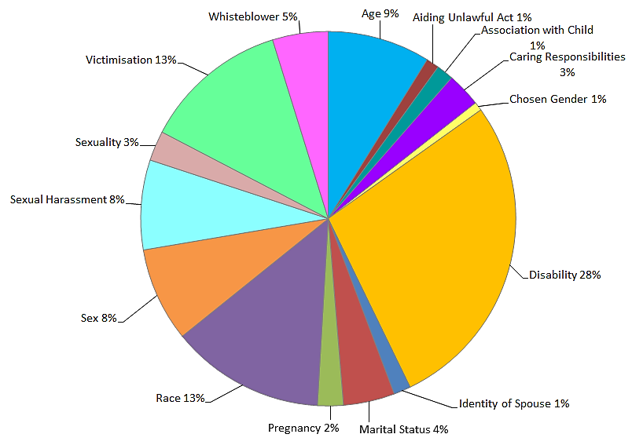

**Complaints lodged 2014-15: Places of discrimination**

Case Study: Role changed after returning from maternity leave

Alice alleges that her role was changed upon her return from maternity leave. She says that upon returning to work she was immediately demoted, she was not given a personal email like everyone else and that she was refused flexible work arrangements. She resigned from her position.

Her employer denied discrimination, explaining that there had been a restructure and that workloads had been changed for business reasons.

A conciliation conference was held and an agreement reached that the employer would provide Alice with the organisation’s policies on equal opportunity matters. The employer also agreed to attend training on equal opportunity matters through the Commission, provide a statement of service and a statement of regret and pay financial damages.

Case Study: Treated unfairly at a venue due to race

Brent, an Aboriginal man, alleged he was treated unfairly by security and staff at an entertainment venue due to his race. He said that an Asian couple received priority service from the valet staff and he was left waiting for an extended period of time for service. Brent says he was told by another staff member at the venue that if he was Asian he would not have been treated this way.

The venue denied any form of race discrimination.

A conciliation conference was held and the matters resolved with the venue agreeing to apologise to Brent, provide a reassurance that all staff are trained in equal opportunity and make a general damages payment.

Case Study: No space for child in special class

Archie's son has a disability. He applied to have his son, Mitchell, enrolled into a special class but was told by the school that children with more serious disabilities have taken the available spaces. Archie says that there are insufficient numbers of places in special classes to meet the demand.

As a result of the complaint, Archie and the principal of the school were able to discuss Mitchell’s needs and the level of support provided was increased.

The complaint resolved as a result of direct discussions between the school and Archie.

\* names have been changed

Whistleblowers

The *Whistleblowers Protection Act 1993* (SA) exists to facilitate the disclosure, in the public interest, of significant maladministration and waste in the public sector and corrupt or illegal conduct generally. It does this by providing a disclosure process and legal protection for those who make disclosures.

The *Whistleblowers Protection Act 1993* (SA) does not protect all disclosures of suspected misconduct, and not everyone who makes a disclosure is a whistleblower. Only a disclosure of ‘public interest information’ is protected. This means a disclosure of illegal activity, an irregular and unauthorised use of public money, substantial mismanagement of public resources or conduct that causes a substantial risk to public health, safety or the environment. Alternatively, public interest information can be maladministration by a public officer in performing official functions.

A disclosure is only protected if it is made to someone to whom it is reasonable to make the disclosure, such as an appropriate authority.

It is unlawful to treat a whistleblower less favourably because he or she has made a disclosure that is protected by the *Whistleblowers Protection Act 1993* (SA). This includes harm, intimidation, harassment, threats of reprisal or any other disadvantage.

If a whistleblower believes that they have been treated unfairly because they ‘blew the whistle’, they can either sue the person for damages in the civil courts or make a complaint of victimisation to the Equal Opportunity Commission.

Over the past year, the Commission received 13 complaints from people who believed that they were whistleblowers protected by the *Whistleblowers Protection Act 1993* (SA) and who alleged victimisation after making disclosures. There were also 11 enquiries received about victimisation of whistleblowers.

**Complaints**

Seven complaints alleging victimisation after making disclosures were accepted in 2014-15.

Fourteen complaints from whistleblowers who alleged they were victimised because they ‘blew the whistle’ were finalised in 2014-15 (seven of these were received in 2013-14). Ten were referred to the Equal Opportunity Tribunal either because conciliation was unsuccessful or it was determined that the matter could not be resolved through conciliation. Four complaints were withdrawn by the complainant.



Complaint Outcomes

**Complaints**

As required under the *Equal Opportunity Act 1984* (SA), the Commission aims to resolve discrimination complaints through conciliation. Complaints that fall under the legislation are allocated to a Conciliation Officer, who will remain impartial and encourage the parties to reach an agreement during a conciliation conference. A variety of outcomes can be negotiated and form a confidential agreement.

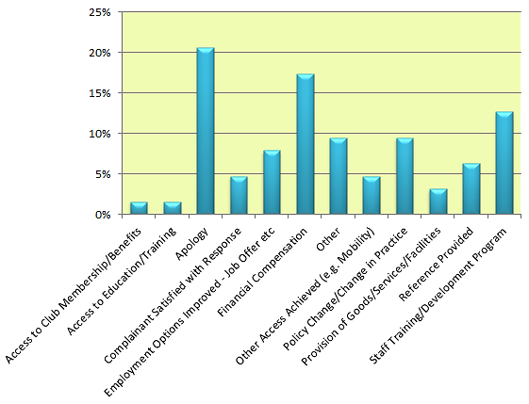Conciliation rates fluctuate from year to year and can be impacted by the complexity of matters and the willingness of parties to come to an agreement. This year, 35% of complaints that fell under the Act were resolved through conciliation.

Complaints referred to the Equal Opportunity Tribunal for determination because they could not be resolved through conciliation accounted for 42%. Twenty per cent of accepted complaints were withdrawn prior to being resolved and 3% were declined.

Many complaints that conciliate are resolved simply by the opportunity to talk about what happened or with an apology. In 2014-15, 43% of conciliated complaints included an apology as part of the settlement agreement.

Other common outcomes include a change to practice that led to the complaint, such as an organisation creating new policies and procedures, or staff attending equal opportunity training. This can help to create workplace cultural change, increase awareness of discrimination issues, and help managers to deal with issues when they arise.

Sometimes people seek financial compensation for loss of wages, medical costs or for hurt and humiliation. Financial compensation is not always large or the main   
part of an agreement. In 2014-15, 37% of conciliated complaints settled with a financial component, which is similar to last year’s figure of 39%. Two agreements were for amounts over $10,000 and compensation amounts ranged from $100 to $17,500.

*Conciliated complaint outcomes 2014-15*

Case Study: Sexual harassment and discrimination matter settles with a number of outcomes

Miriam\* alleged that she was sexually harassed and discriminated against because of her sex and her pregnancy in her employment.

Miriam stated that her employer made inappropriate comments, including that she was beautiful and suggesting that she take off her clothes if hot. Miriam also alleged unwelcome touching, negative comments about being pregnant, and verbal abuse. Miriam resigned from her position.

A conciliation conference was held and the matter was resolved. The employer did not provide a response however and, at conference, denied the allegations.

The matter was settled for a statement of regret, a statement of service and a general damages payment to Miriam. The employer also agreed to introduce equal opportunity policies and attend training.

*\* names have been changed*



Our Service

Every year, the Commission seeks feedback from both complainants and respondents about their experience of our complaint handling process.

Evaluation surveys look at performance indicators including the information we provide, the time it takes to resolve complaints, impartiality and overall satisfaction with the process.

In 2014-15, the majority of both complainants and respondents who returned an evaluation survey were satisfied with the Commission’s complaint handling overall - 83% of complainants and 100% of respondents.

During the complaint process, the Commission provides information to assist both parties to understand what is happening. This includes providing fact sheets and conciliation information, as well as keeping parties up to date. Conciliation officers also often spend time explaining complex discrimination issues to parties and answering queries about the process. Of those who completed evaluations, 92% of complainants and 96% of respondents agreed that they were well-informed throughout the process.

*I was assisted in my complaints process by [my conciliation officer] in understanding the process and where to go for help with my case. [My conciliation officer] made me feel at ease and ensured both parties were allowed to speak and be heard which made the stressful event feel manageable for all concerned. The result was based on all parties and strength of conviction, not due to any bias. Thank you.****- Complainant***

Addressing the expectations of both parties and maintaining neutrality is also an important part of complaint handling at the Commission.

*Professional, courteous and prompt.  
[Our conciliation officer] did a wonderful job!***- Respondent**

**Complaints**

People who complain are sometimes surprised that the Commission does not act as their advocate, while respondents also often think that the Commission will be acting for the complainant. Fair treatment for all is paramount in our service. In 2014-15, 94% of complainants and 100% of respondents felt that the Commission’s complaint process was impartial and did not favour either party.

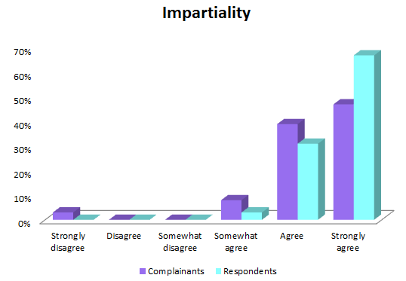

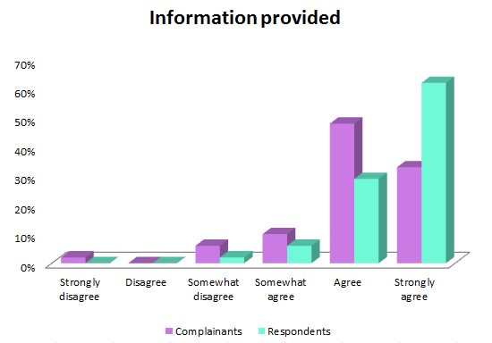

The Equal Opportunity Tribunal

**Complaints**

The Equal Opportunity Tribunal has two main roles under the *Equal Opportunity Act 1984* (SA). It hears complaints referred to it by the Equal Opportunity Commissioner and applications for exemptions.

The Tribunal is a separate body from the Commission. It comprises a Presiding Member, who is a District Court Judge, and two assessors, who are lay people chosen for their skills and experience.

During the 2014-15 period, the Tribunal handed down five decisions and granted four exemptions. Details of Tribunal decisions and referrals are set out in the following pages.

### Exemptions from the Act

The *Equal Opportunity Act 1984* (SA) (‘the Act’) allows organisations to apply to the Equal Opportunity Tribunal for a temporary exemption from the Act. The Tribunal can order an exemption of up to three years, and an organisation can lawfully discriminate according to the conditions of the exemption.

The Tribunal granted the following exemptions, including extensions to existing exemptions, in 2014-15:

**ASC Pty Ltd & Others [2014] SAEOT 2 (4 July 2014)**

ASC Pty Ltd, ASC Shipbuilding Pty Ltd and ASC AWD Shipbuilder Pty Ltd applied for a renewal of their existing exemption from Section 52, 54 and 103 (1) (discrimination on the basis of nationality and country of origin) of *the Equal Opportunity Act 1984* (SA).

The Tribunal granted the exemption extension for a further three years, ordering the applicants to update their employment practices generally and their Equal Opportunity Exemption Order Policy and Procedure Manual, in particular, to reflect the terms of the renewal of the exemption and train relevant staff. The applicants are also required to provide a report to the Equal Opportunity Commission six months after the grant date of the exemption and must then report annually. Read the judgement at: [www.austlii.edu.au/au/cases/sa/SAEOT/2014/2.html](http://www.austlii.edu.au/au/cases/sa/SAEOT/2014/2.html)

**BAE Systems Australia Ltd [2014] SAEOT 3 (29 August 2014)**

BAE Systems Australia applied for renewal of their exemption, previously granted, to enable it to discriminate on grounds of nationality (*Equal Opportunity Act 1984*, ss 52, 54, 92). This was a result of United States legislation which requires local companies working on US defence contracts to employ only Australian citizens. The exemption was granted for a further period of a three years subject to conditions. Read the judgement at: [www.austlii.edu.au/au/cases/sa/SAEOT/2014/3.html](http://www.austlii.edu.au/au/cases/sa/SAEOT/2014/3.html)

**Raytheon Australia Pty Ltd [2014] SAEOT 5 (13 October 2014)**

Application for a renewal of an existing exemption from the provisions of s 52 and s 54 of the *Equal Opportunity Act 1984* (SA). The applicant sought an exemption so as to lawfully discriminate against its prospective employees and contractor workers on the grounds of nationality. The applicant's business activities require access to highly sensitive defence related material controlled by the government of the United States of America. The exemption is sought on the basis of the likely impact on the defence capacity of Australia, and the public interest.

****The exemption was granted for a period of a three years from 4 July 2014 subject to conditions. Read the judgement at: [www.austlii.edu.au/au/cases/sa/SAEOT/2014/5.html](http://www.austlii.edu.au/au/cases/sa/SAEOT/2014/5.html)

**Courts Administration Authority [2015] SAEOT 3 (22 April 2015)**

The Courts Administration Authority applied for an exemption from the provisions of s 30 of the *Equal Opportunity Act 1984* to enable it to employ only female legal practitioners in its *Step Up to the Bar* Program. The Courts Administration Authority argued that positive discriminatory measures are necessary to redress the current gender imbalance in favour of males at the Independent Bar in South Australia and that the grant of application will promote equality of opportunity for female legal practitioners wishing to pursue a career at the Bar.

The Tribunal granted an exemption for three years from 13 April 2015. Read the judgement at: [www.austlii.edu.au/au/cases/  
sa/SAEOT/2015/3.html](http://www.austlii.edu.au/au/cases/sa/SAEOT/2015/3.html).

Complaints referred to the Tribunal

**Complaints**

If parties fail to reach agreement through the Commission’s conciliation process, the Commissioner can either decline a complaint or refer it to the Tribunal. If the Commissioner refers a complaint to the Tribunal, the complainant can ask the Commissioner to provide them with legal assistance. The Commissioner can then decide whether or not to fund legal assistance for the complainant or respondent.

The Commissioner can choose not to provide financial assistance if parties can afford their own legal representation or if the case is unlikely to be successful.

### Cases referred to the Tribunal with full or partial assistance

If legal assistance is provided, the Commissioner can choose to partially fund a complaint (complainant or respondent), rather than fully fund it. Situations where this may occur include where the Commissioner receives advice that the complaint is unlikely to be successful.

Four complainants had their cases partially or fully funded for complaints referred to the Tribunal in 2014-15.

**Gibbons v Department for Education and Child Development & Dansie - DCCIV-14-1744 (Fully funded)**

*- Sex discrimination and Aiding unlawful act*

Awaiting Tribunal hearing.

**Demin v Westpac Banking Corporation - DCCIV-14-1914 (Partially funded)**

*- Race discrimination*

The complaint was discontinued by the complainant on 29 June 2015.

**Pettingill v Pawnbroker Services - DCCIV-14-1915 (Partially funded)**

*- Age and Disability discrimination*

Struck out by the Tribunal following correspondence from the complainant stating that she was unable to get to the Court followed by non-appearance by the complainant or a representative at a preliminary hearing on 29 April 2015.

**Parker v Transfield Services (Australia) - DCCIV-14-2067 (Fully funded)**

*- Chosen Gender and Disability discrimination*

Settled by agreement between the parties and discontinued by the complainant on 9 July 2015.

### Cases referred to the Tribunal without assistance

If the Commissioner declines a complaint, the complainant has a right under the Act to take their complaint to the Tribunal. In these cases, they do not receive financial assistance from the Commissioner and can either represent themselves or engage a lawyer to represent them.

In 2014-15, 34 complaints which were referred to the Tribunal and registered were not funded by the Commissioner. Note that a number of complaints made by one complainant may be registered as one Tribunal matter if they are related.

In 2014-15, the following “unfunded” complaints were referred to the Tribunal:

**Mirdoolati v TAFE SA Adelaide North Institute - DCCIV-14-1232**

*- Pregnancy discrimination*

Discontinued by the complainant on 18 November 2014.

**Downing v Women’s and Children’s Health Network - DCCIV-14-1620**

*- Disability discrimination*

Discontinued by the complainant on 9 December 2014.

**Ingham v Department for Planning, Transport & Infrastructure, Mohammed Elgazzar, David Bernard, Michelle Kappler - DCCIV-15-256 & DCCIV-14-1291**

*- Victimisation as a whistleblower*

Discontinued by the complainant on 3 March 2015.

**Simpson v Australian Health Practitioner Regulation Agency and Nursing & Midwifery Board of Australia - DCCIV-14-296 & DCCIV-14-1458**

*- Race discrimination*

Discontinued by the complainant on 9 April 2015.

**Clarke v South Australia Police - DCCIV-14-1066**

*- Disability discrimination*

Discontinued by the complainant on 6 May 2015.

**Selth v Department for Communities and Social Inclusion - DCCIV-14-1647**

*- Disability discrimination*

Awaiting Tribunal hearing.

**Blight v Women’s and Children’s Health Network - DCCIV-14-1765**

*- Sex and Disability discrimination*

Awaiting Tribunal hearing.

**De Ieso v Department for Health and Ageing and Others - DCCIV-14-1912**

*- Victimisation as a whistleblower*

Awaiting Tribunal hearing.

**Hasse v Clare and Gilbert Valleys Council - DCCIV-14-1913**

*- Disability discrimination*

The complainant did not appear at two scheduled hearings. The complaint was dismissed by the Tribunal on 13 May 2015.

**Bishop v Whyalla Netball Association - DCCIV-14-1916**

*- Sex discrimination*

Discontinued by the complainant on 6 July 2015.

**Walker v Aboriginal Family Support Services and Others - DCCIV-14-1917**

*- Victimisation*

Discontinued by the complainant on 7 July 2015.

**Palmer v Unity Housing Association - DCCIV-14-2066**

*- Disability discrimination*

Discontinued by the complainant on 20 February 2015.

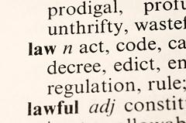**Sellen v TNT Australia Pty Ltd - DCCIV-14-2068**

*- Disability discrimination*

Awaiting Tribunal hearing.

**Richards v SA Health - DCCIV-15-81**

*- Chosen Gender discrimination*

Awaiting Tribunal outcome.

**Keyburg v TAFE SA - DCCIV-15-82**

*- Disability discrimination*

The complainant did not appear at two scheduled hearings. The complaint was dismissed by the Tribunal on 13 May 2015.

**Richards v Department for Correctional Services - DCCIV-15-84**

*- Chosen Gender discrimination*

Awaiting Tribunal outcome.

**Scotland v The City of Unley - DCCIV-15-112**

*- Disability discrimination*

Awaiting Tribunal hearing.

**Viney v Department for Education and Child Development - DCCIV-15-113**

*- Identity of Spouse and Marital Status discrimination*

As at 30 June 2015, the matter was awaiting Tribunal hearing.

**McIver v South Coast Swimming Club Inc - DCCIV-15-114**

*- Disability discrimination*

Settled by agreement between the parties on 15 April 2015 and discontinued by the complainant.

**Easton v El-Jasbella Pty Ltd trading as Edenfield Family Care - DCCIV-15-372**

*- No EO ground identified*

Discontinued by the complainant on 23 April 2015.

**Gupta v Department for Education and Child Development - DCCIV-15-836**

*- Age discrimination*

Awaiting Tribunal hearing.

**Mogridge v Gull Truck Stop - DCCIV-15-837**

*- Race discrimination*

Awaiting Tribunal hearing.

Tribunal Decisions in 2014-15

**RAMSTROM v BALDINO [2014] SAEOT 4 (9 October 2014)**

On 20 December 2013, a complaint brought by Ms Ramstrom alleging sexual harassment by Mr Baldino was dismissed. The respondent applied for an order for costs on the basis that the proceedings brought by the complainant were frivolous or vexatious. The Tribunal held that there was no basis for determining the complainant's claim was either frivolous or vexatious. The application was refused.

**Complaints**

Read the full judgement at:

[www.austlii.edu.au/au/cases/sa/SAEOT/2014/4.html](http://www.austlii.edu.au/au/cases/sa/SAEOT/2014/4.html)

**HALIMEE v SANTARELLI T/A SEASIDE SALON [2014] SAEOT 6 (23 October 2014)**

Ms Halimee was an apprentice hairdresser employed by Ms Santarelli at the Seaside Salon. Her employment at the salon was terminated some 3 months after Ms Halimee informed her employer that she was pregnant. Ms Halimee claimed that she had been discriminated against on the grounds of her pregnancy, in particular:

* when she advised her Ms Santarelli that she was pregnant, Ms Santarelli said she did not know what to do with her or how she could “keep her”;
* when she expressed concern about applying spray tans and provided doctor’s advice that she should not do so whilst pregnant, that Ms Santarelli told her she was “using her pregnancy as an excuse” to avoid work;
* that her employer’s attitude towards her changed dramatically after she was advised of her pregnancy;
* that the termination of her employment was because of her pregnancy.

At the hearing, the Tribunal overall preferred the evidence of Ms Halimee over that of Ms Santarelli (who gave conflicting evidence) and found that whilst not all of the allegations were made out or amounted to discrimination on the grounds of pregnancy, overall they were satisfied that Ms Santarelli’s conduct towards Ms Halimee changed upon learning that Ms Halimee was pregnant.

Further, they found that this change in conduct, combined with Ms Santarelli’s attempted termination of Ms Halimee’s employment, constituted unlawful conduct under the Equal Opportunity Act and noted that “once she knew Ms Halimee was pregnant, she treated her, in the work context, with an element of suspicion and distance which had not previously been present between them”.

Ms Halimee was awarded $5,000 for injury to feeling.

Read the full judgement at:

[www.austlii.edu.au/au/cases/sa/SAEOT/2014/6.html](http://www.austlii.edu.au/au/cases/sa/SAEOT/2014/6.html)

**RAGLESS v STOKES [2015] SAEOT 1 (12 March 2015)**

Mr Ragless complained that he had been victimised by Mr Stokes following his disclosure of an incident at a shooting club, of which he was a member, between himself and the Secretary of his club. Mr Ragless made a complaint under the *Whistleblowers Protection Act* (WPA) and *Equal Opportunity Act* claiming victimisation by the respondent.

The Tribunal determined that the disclosure made by the complainant did not constitute an appropriate disclosure of public interest information within the meaning of the WPA. The complaint was dismissed.

Read the full judgement at:

[www.austlii.edu.au/au/cases/sa/SAEOT/2015/1.html](http://www.austlii.edu.au/au/cases/sa/SAEOT/2015/1.html%20)

**RAGLESS v OFFICE OF THE POLICE OMBUDSMAN [2015] SAEOT 2 (12 March 2015)**

Mr Ragless complained that he had been victimised by the Office of the Police Ombudsman following his disclosure of a failure by the Firearms Branch of South Australian Police to investigate properly an incident which the complainant said occurred on the firearms range of his shooting club and the allegedly illegal behaviour of some officials at his club. Mr Ragless made a complaint under the *Whistleblowers Protection Act* (WPA) and *Equal Opportunity* Act claiming victimisation by the respondent. Mr Ragless asserted that the respondent failed to properly investigate his concerns.

The Tribunal found that, even on the assumption that the information disclosed was public interest information within the meaning of the WPA, it was not reasonably arguable that the respondent committed an act of victimisation in that any detriment suffered was not caused on the ground of his disclosure. The complaint was dismissed.

Read the full judgement at:

[www.austlii.edu.au/au/cases/sa/SAEOT/2015/2.html](http://www.austlii.edu.au/au/cases/sa/SAEOT/2015/2.html).

**HILES v ALLITY (LITTLE PARA) P/L [2015] SAEOT 4 (15 May 2015)**

Mr Hiles made a complaint to the Equal Opportunity Commission that he had been victimised on the basis of being a "whistleblower” following his reporting of an assault at an Aged Care facility. The complaint was unable to be conciliated and was referred to the Tribunal. The respondent applied to strike out the complaint on the grounds that it does not identify a cause of action pursuant to the *Equal Opportunity Act 1984* (SA).

The ground for the respondent’s application to dismiss the proceedings was that Mr Hiles complaint did not fall under the *Whistleblowers Protection Act 1993* because the incident that Mr Hiles witnessed and reported, and which, Mr Hiles asserted, constituted “unlawful activity” under the *Whistleblowers Protection Act 1993*, was not, in fact, an assault, and did not constitute “unlawful activity”.

The Tribunal granted the respondent’s interlocutory application and the complaint was dismissed.

Read the full judgement at:

[www.austlii.edu.au/au/cases/sa/SAEOT/2015/4.html](http://www.austlii.edu.au/au/cases/sa/SAEOT/2015/4.html)

Other Tribunal Matters Finalsised in 2014-15

**Lynch v Department for Education and Child Development - DCCIV-13-414**

*- Disability discrimination*

Discontinued by the complainant on 30 January 2015.

**Bakarich-Christie v Clipsal Australia Pty Ltd - DCCIV-13-1222**

*- Disability and pregnancy discrimination*

Settled by agreement between the parties on 21 November 2014.

**Gordon v Department for Education and Child Development - DCCIV-13-1883**

*- Disability discrimination*

Settled by agreement between the parties and discontinued by the complainant on 6 March 2015.

**Bone-George v Department for Education and Child Development - DCCIV- 13-2905**

*- Disability discrimination*

Discontinued by the complainant on 17 September 2014 as the issues in dispute between the parties had been resolved.

**Paterson v TAFE SA, Lawrence Udo-Ekpo - DCCIV-14-243**

*- Review of Commissioner’s decision*

Discontinued by the complainant on 9 July 2014.

**Ingham v Department for Planning, Transport & Infrastructure, Rod Hook, Judith Carr, Lino di Lernia, David Bernard - DCCIV-13-2763, DCCIV-14-250**

*- Victimisation as a whistleblower*

Discontinued by the complainant on 3 March 2015.

**Cowie v Central Adelaide Local Health Network (CALHN), Dr Peter Steele, Mr Michael Cursaro - DCCIV-14-623**

*- Disability discrimination and Victimisation as a whistleblower*

Discontinued by the complainant on 13 May 2015.

**Ali v I-Sec Pty Ltd - DCCIV-14-785**

*- Race discrimination*

Parties failed to appear at a preliminary hearing in July 2014. Discontinued by the complainant on 10 July 2014.

**Holmes v SA Prison Health Service part of Central Adelaide Local Health Network - DCCIV-14-786**

*- Disability discrimination*

Withdrawn by the complainant at the preliminary hearing on 9 July 2014 because his situation had changed.

**Davidson v Department for Education and Child Development - DCCIV-14-1023**

*- Victimisation as a whistleblower*

Discontinued by the complainant on 13 October 2014.

**Marshall v SA Health - DCCIV-14-1024**

*- Disability discrimination*

Discontinued by the complainant on 13 April 2015.

**Simpson v Australian Health Practitioner Regulation Agency (AHPRA) and Nursing & Midwifery Board of Australia (NMBA) - DCCIV-14-296 & DCCIV-14-1458**

*- Race discrimination*

Discontinued by the complainant on 9 April 2015.

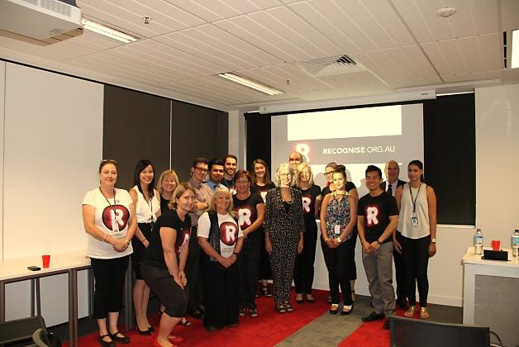

Programs

Training and Community Education 41

Diversity at Work 43

National Anti-Racism Strategy in South Australia 44

Chiefs for Gender Equity 46

Greatest Asset Project 47

Websites 49

Social Media 51

Story 1 20

Story 2 21

Story 3 22

Story 4 23

Story 5 24

Story 6 25

Story 7 26

Training and Community Education

**Programs**

The Commission provides various education and training services. Services include:

* in-house training courses
* customised training for organisations and workplaces
* education and information sessions for the community.

### In-house courses

A number of training courses and workshops are offered by the Commission throughout the year. Information about each of these courses is available on the Commission’s website under ‘current training courses.’ Training is held at the Commission’s office in Adelaide’s central business district. Training for contact officers and sessions on effectively managing workplace issues are the most popular public courses.

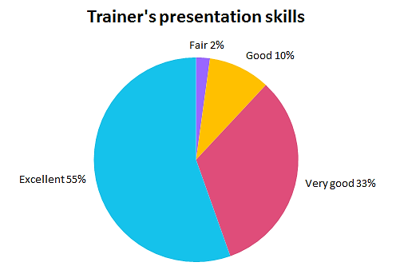The Commission’s training programs continue to be very well received, generating positive feedback from attendees. In 2014-15, 85% of people attending training at the Commission rated courses as being excellent or very good, and 92% said they would recommend the training to others. Eighty-eight percent of in-house training attendees rated the trainer’s presentation skills as very good or excellent.

### Training for organisations and workplaces

Customised training is also available and it can be tailored for individual workplaces. Commission training officers work closely with organisations to ensure their program is relevant and effective. The Commission offers workplace training:

* for individuals or groups
* for managers
* on specific topics

Training includes reviewing workplace policies and procedures, developing an equal opportunity plan, completing an assessment of the workplace culture and supporting organisations to conduct their own training in the future.

The Commission also offers e-Learning training programs to better suit the demands of the modern workforce.

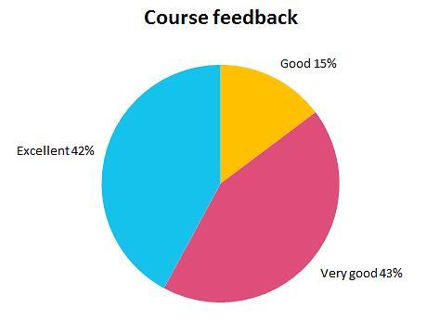

### Information for the community

The Commission presents information to the community regarding their rights and responsibilities through community education sessions. The Commission, for example, conducts regular sessions through TAFE’s Interlink program for new arrivals. Commission staff are also regular guests on Radio Adelaide and Coast FM discussing current issues of discrimination.

The Commission works with community organisations to raise awareness of equal opportunity and build the capacity of organisations to better manage issues around discrimination, diversity and equal opportunity. Organisations we worked with in 2014-15 included:

* TAFE
* SCOSA
* Australian Education Union - SA Branch
* Workcover SA
* Barossa Valley Council
* City of Port Adelaide Enfield
* Metropolitan Fire Service
* Department of Primary Industries and Resources of South Australia (PIRSA)
* Department of Planning, Transport and Infrastructure

The Commission also partnered with the Disability Advocacy and Complaints Service of SA Inc. (DACSSA) on a stall at the Adelaide Disability & Lifestyles Expo in November 2014. Events such as this are a great opportunity to provide individuals and service providers with information about rights, responsibilities, and options for making and resolving complaints.

*“Very engaged in the training all day (which went very quickly). Great trainer, very knowledgeable.”*

**- Training participant**

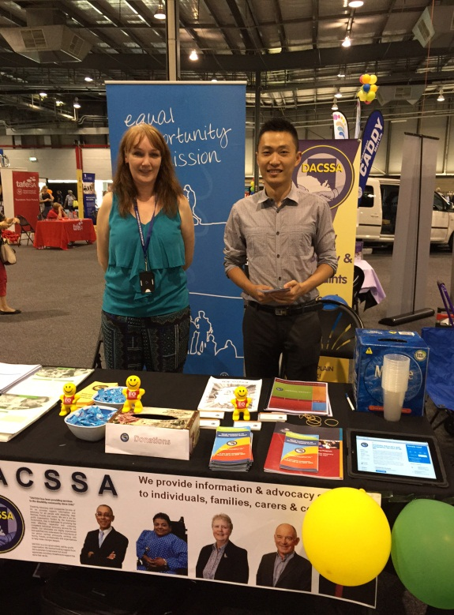

*Equal Opportunity Commission’s Corina Mulholland and DACSSA’s Fu Cheng Yu at the 2014 Adelaide Disability & Lifestyles Expo*

Diversity at Work

**Programs**

In March 2015, Equal Opportunity Commission Conciliation and Training Officer Robyn Dwight was guest speaker at a [SafeWork SA](http://www.safework.sa.gov.au/) Library and Resource Centre’s *Food 4 Thought* information session. These free lunchtime information sessions highlight workplace issues or hazards of relevance to people working or living in the Adelaide CBD.

Robyn’s session focused on discrimination and diversity in the workplace. Robyn provided tips on how to create an inclusive workplace and talked about the importance of promoting fairness, as well as dealing effectively with complaints.

Robyn’s presentation included the following ‘Seven steps for employers’:

1. Treat employees and customers fairly in your dealings with them
2. Have a policy which rules out discrimination and sexual harassment
3. Have a procedure to deal with complaints
4. Tell your customers and employees about it regularly
5. Handle complaints quickly, fairly and confidentially
6. Consider making an employee an Equal Opportunity contact person
7. Monitor and maintain a culture of Equal Opportunity

You can view Robyn’s presentation at: [www.youtube.com/watch?v=f4-m3MRXQMg](https://www.youtube.com/watch?v=f4-m3MRXQMg).

The Commission can present similar sessions on request. It can also tailor half and full-day sessions for organisations. Find more information about our regular and customised training at:

[www.eoc.sa.gov.au/eo-business/training](http://www.eoc.sa.gov.au/eo-business/training%20).

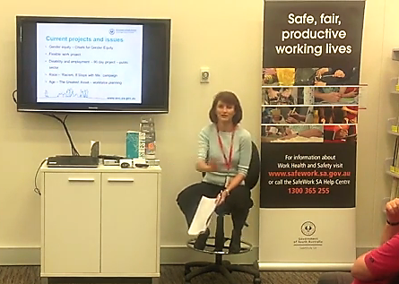 *Conciliation and Training Officer Robyn Dwight presenting her Food 4 Thought information session*

National Anti-Racism Strategy in South Australia

**Programs**

In 2012, the Australian Human Rights Commission (AHRC) launched a national anti-racism strategy. Implementation of the strategy commenced in July 2012 and was funded for a three year period until July 2015. The strategy has secured further funding and was relaunched by AHRC in mid-2015.

All South Australian campaign supporters were invited to celebrate their contribution to the anti-racism message and participation in the ‘Racism. It Stops with Me’ campaign at a supporter event hosted by Race Discrimination Commissioner, Dr Tim Soutphommasane in March 2015. The event attracted a number of campaign supporters and included presentations of action taken by various groups.

The Australian Human Rights Commission is now leading the second stage of the Strategy and campaign. Work will fall under two distinct but complementary themes:

* Combating racism and discrimination; and
* Supporting diversity and inclusion.

The Equal Opportunity Commission continues to lead the promotion and implementation of the strategy and campaign in South Australia for the second stage. The Commission’s focus is to encourage new supporters to sign up to the campaign, whilst also continuing its engagement with all government agencies.

South Australian supporters now exceed 35 and include Local Government, community and sporting organisations and South Australian businesses.

*Commissioner Anne Gale with John Kernahan (CEO, SAAFL) and Tim Soutphommasane at the South Australian Amateur Football League sign up to the campaign on 13 March 2015*

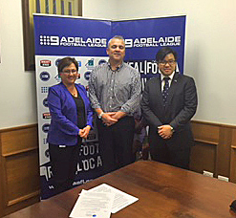

### The South Australian Government

On 10 December 2013, the South Australian Premier Jay Weatherill and all SA government Chief Executives signed the National Anti-Racism Campaign Supporter Agreement pledging their support of the National Anti-Racism Strategy.

Implementation and governance of this commitment has been through the Safe Communities, Healthy Neighbourhoods Cabinet Taskforce. The Commissioner for Equal Opportunity, Anne Gale, has been coordinating an across government group to oversee the implementation of the Strategy within each agency. This Implementation Group has met on a quarterly basis since 1 May 2014. The Implementation Group brings together executives from across government to discuss and report on each department’s implementation of the Strategy, and in particular the ‘Racism. It Stops with Me’ campaign.

Actions taken by departments include:

* **Campaign specific activities**: Departments have placed promotional materials, such as posters, in high traffic areas in public sector workplaces and in customer service areas such as Service SA centres. Social media has also been utilised to directly link to the campaign. Many departmental intranets and websites promote the campaign and link to the campaign website. The Department of Planning, Transport and Infrastructure has specifically linked intranet news articles to publicise the campaign.
* **Cultural events**: Most departments encourage and support staff to attend relevant cultural events, including Reconciliation Week and NAIDOC week events such as the Apology Anniversary breakfast. It has been noted that promoting and recognising relevant annual multicultural events is a simple and effective way to demonstrate support for people from diverse cultural backgrounds.
* **Training and recruitment**: Departments have included the strategy in their online induction tools or as part of an induction pack. Some departments have set targets in relation to the recruitment of Aboriginal and Torres Strait Islander people, and many departments have implemented training and awareness about cultural diversity and cultural competence for staff and managers.

### Round tables

The Commission continues to host roundtables with peak multicultural and Aboriginal bodies. To date, 12 roundtables have been held and there is an ongoing commitment from members to continue these meetings.

The roundtable has identified a number of priority areas in order to counter racism effectively in South Australia. These priority areas align with those identified in the National Anti-Racism Strategy. The Equal Opportunity Commission has committed to hosting forums on these identified areas of interest in order to develop a better understanding of what can be achieved by organisations and agencies.

A forum on the topic of Cyber Racism and Social Media will be held in September 2015.

Find out more about the ‘Racism. It Stops with Me’ campaign at:

[itstopswithme.humanrights.gov.au/](http://itstopswithme.humanrights.gov.au/)

Chiefs For Gender Equity

**Programs**

The Chiefs for Gender Equity are South Australian male business leaders committed to improving gender equity in their businesses, industry sectors and for the state.

Priority areas for 2014-15 included:

* Flexible work
* Job design
* Gender Pay Equity Audits
* 50/50: if not, why not
* Women in non-traditional roles
* Inclusion
* Sponsorship
* Research
* 2015 engagement series

In recognition of the gender pay gap, the Chiefs undertake wage gap analyses and develop strategies to reduce the gap in their businesses. On Equal Pay Day, 5 September 2014, a number of the Chiefs committed to sign the United Nations Women’s Empowerment Principles (WEPs), hosted by BankSA Chief Executive Nick Reade. The Minister for Women, the Hon Gail Gago MLC spoke at the event.

The UN WEPs are a framework for gender equality and are practical ways of investing, advancing and empowering women in the workplace. In Australia, at that time, there were 16 signatories to the WEPs.

The principles are:

1. Establish high-level corporate leadership for gender equality
2. Treat all women and men fairly at work - respect and support human rights and non-discrimination
3. Ensure the health, safety and wellbeing of all women and men workers
4. Promote education, training and professional development for women
5. Implement enterprise development, supply chain and marketing practices that empower women
6. Promote equality through community initiatives and advocacy
7. Measure and publicly report on progress to achieve gender equality

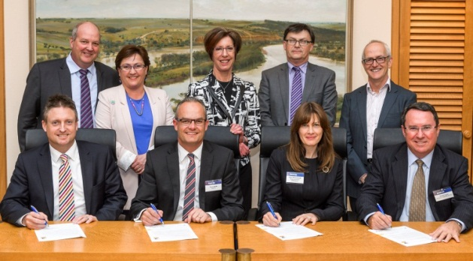

At the event, Chiefs Nick Reade, BankSA; Con Tragakis, KPMG; David Martin, Finlaysons; and Rob Stobbe, SA Power Networks, committed their businesses to the seven WEP principles. Business SA and Parsons Brinckerhoff are existing signatories.

In December 2014, the Chiefs committed to an engagement series for 2015 including listening forums with staff, and engaging with businesses and the Premier’s Council for Women. This work is underway with most completing their internal listening forums to date.

During the year, the Chiefs launched their webpage at: [www.eoc.sa.gov.au/eo-business/chiefs-gender-equity](http://www.eoc.sa.gov.au/eo-business/chiefs-gender-equity).

Greatest Asset Project

**Programs**

South Australia has the second oldest population in Australia, after Tasmania. Within 30 years, almost a quarter of the population will be aged over 65.

In support of *Prosperity through Longevity: South Australia’s Ageing Plan 2014 - 2019*, the Office for the Ageing funded the Commission to work with key employment industry groups, the Australian Industry Group, and Don’t Overlook Mature Expertise (DOME) to raise awareness of, and combat, age discrimination in employment.

The Greatest Asset: Overcoming Age Discrimination Project aimed to maximise employment opportunities for South Australians over the age of 45 years through a range of strategies including awareness raising, promoting the value of an older workforce, implementing workforce planning, and addressing age discrimination.

The project challenged employer and employee assumptions about mature age workers, including expectations of their intentions to retire, based on age.

A review of existing material, along with consultation with key stakeholders, assisted in the development of an online tool for employers. This free educational resource was developed to help prevent and/or reduce age discrimination in recruitment and employment. The tool, available online, helps to support workforce planning and transition planning and contains a list of useful resources.

A simple online tool was also developed for employees. The tool aims to encourage employees (and prospective employees) to think about what they are looking for in terms of their shorter and longer-term employment future, the skills they have to offer an employer, and where the job market may be heading.

Two practical workshops were also held to strengthen employer awareness of the project, while at the same time developing employer capability to undertake workforce planning on their mature age workforce. These workshops (‘*Maximising opportunities to retain and attract the workforce you need*’) were delivered by Workforce Planning Global Chief Executive, Julie Sloan, in the Upper Spencer Gulf Region and Glenelg.

Both the employer and employee tools are now available on the Equal Opportunity Commission’s website at: [www.eoc.sa.gov.au/eo-resources/greatest-asset](http://www.eoc.sa.gov.au/eo-resources/greatest-asset).

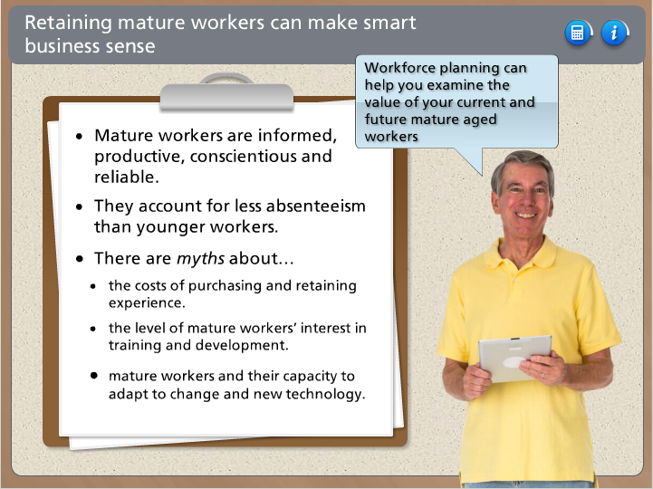

*Screenshot from the Greatest Asset employer tool which is available on the Commission’s website*

Case Study: Too old to operate a forklift

Henry\* is 58 years old and alleged that he was not hired because of his age and because he has arthritis.

Henry applied for work as a forklift operator with a large company but was told that he would not be employed because of his age (they prefer younger fitter workers) and his disability (he was told that he could hurt himself getting on and off the forklift).

A conciliation conference was held and an agreement between the two parties was reached. The manager of the company provided a verbal apology for any hurt or distress caused to Henry, and promised to look at improving recruitment information provided to job candidates. He also offered Henry the opportunity to reapply for work with the company if he was interested in the future.

*\* names have been changed*

Websites

**Programs**

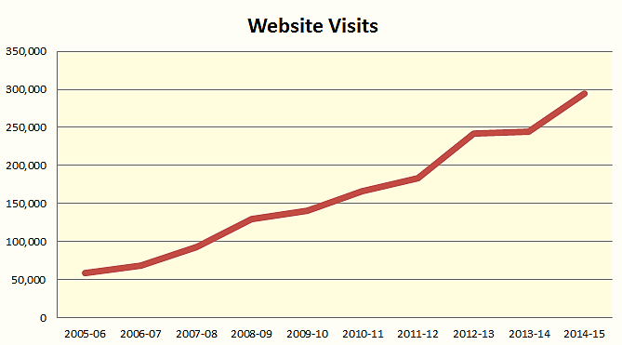The Commission has two websites - the main Equal Opportunity Commission website ([www.eoc.sa.gov.au](http://www.eoc.sa.gov.au)) and EO 4 Schools ([www.eo4schools.net.au/](http://www.eo4schools.net.au/)). EO 4 Schools contains equal opportunity and human rights information for students and includes online activities such as quizzes and crosswords.

In 2014-15, our websites were visited over 293,000 times – more than 800 times a day. This was a 20% increase in visits from the previous year. There were 41,018 visits to the EO 4 schools website and 252,945 visits to the EOC website.

Website visits have increased every year over the past decade, as more people utilise online resources. There were over 110,00 downloads from our websites in 2014-15. The 20 most popular files can be seen in the table below.

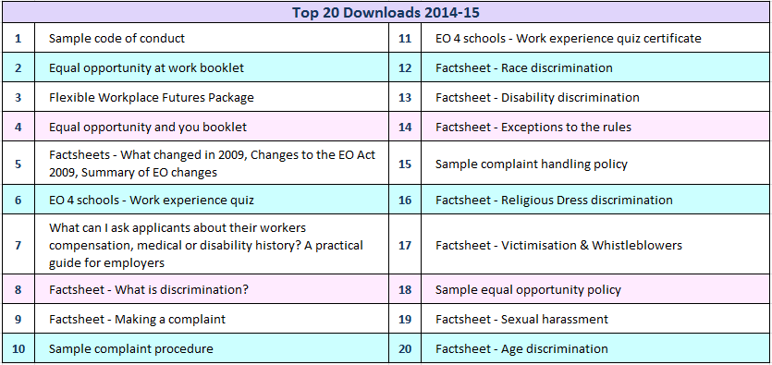Resources available on the Equal Opportunity Commission websites are growing and include information and publications produced as a result of our projects such as the Flexible Workplace Futures package and

the Greatest Asset employer and employee tools.

People also visit our websites for a range of information including factsheets, policies and procedures, case studies, training videos, and online courses and quizzes.

Lists of the most popular pages and the top searches hitting our websites appear on the following page. The most popular topics include cultural differences in the workplace, dress codes and equal opportunity laws.

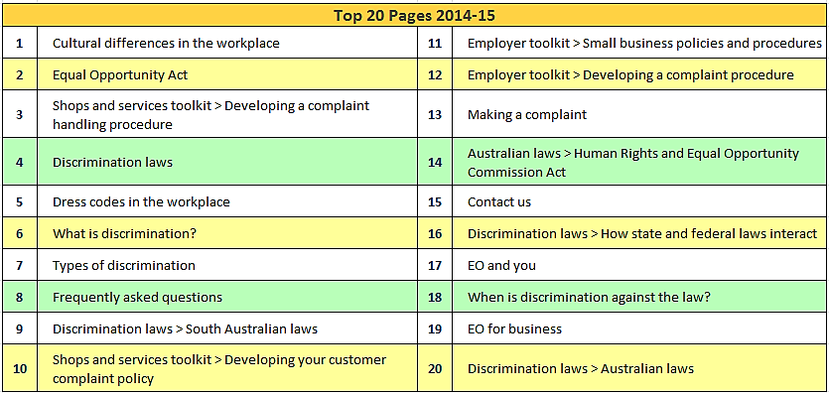

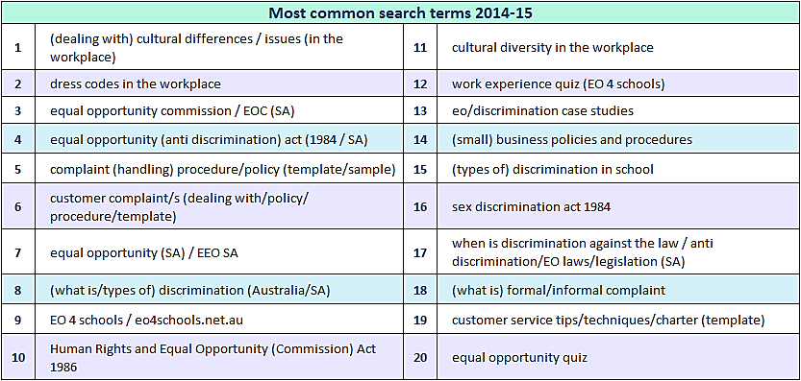

Social Media

**Programs**

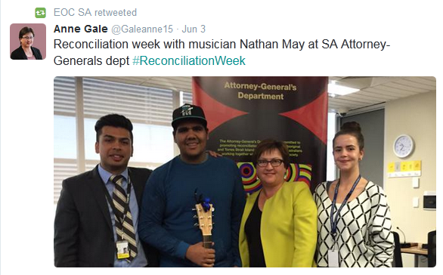The Equal Opportunity Commission has a Facebook page and Twitter, both with a growing number of followers. Commissioner Anne Gale also has a Twitter account.

This year, the Commission’s Facebook and Twitter audiences grew by more than 150%. The Commission uses its social media presence to engage with organisations and the community, not only about Commission activities and events, but also to share topical information from a range of sources related to equal opportunity, anti-discrimination, and human rights.

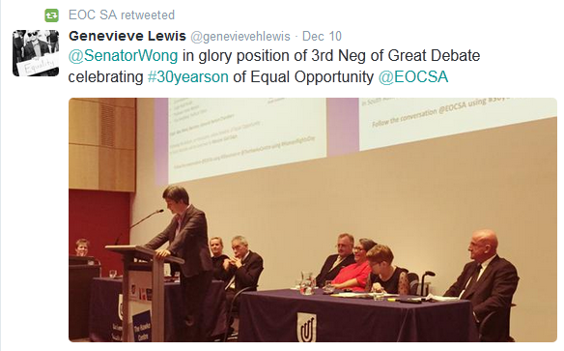

Follow the Equal Opportunity Commission on Twitter ([twitter.com/eocsa](https://twitter.com/eocsa)) or like our [Facebook page](https://www.facebook.com/pages/Equal-Opportunity-Commission-of-South-Australia/325106495557) ([www.facebook.com/pages/Equal-  
Opportunity-Commission-of-South-Australia/325106495557](http://www.facebook.com/pages/Equal-Opportunity-Commission-of-South-Australia/325106495557)).

Follow Commissioner Anne Gale on Twitter - [twitter.com/galeanne15](https://twitter.com/galeanne15).

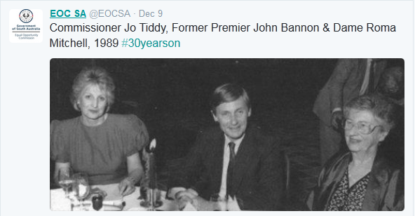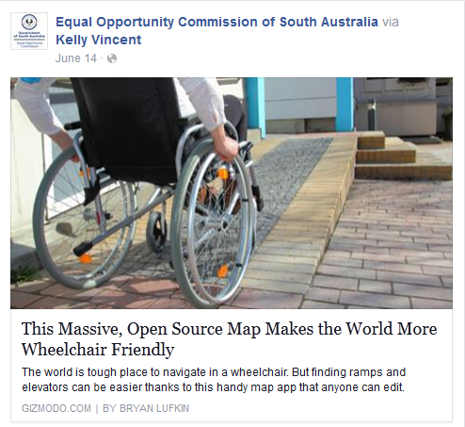



Address Level 17, 45 Pirie Street  
 Adelaide SA 5000

Phone (08) 8207 1977

E-mail eoc@agd.sa.gov.au

Website **www.eoc.sa.gov.au**

The Equal Opportunity Commission provides three main services in   
South Australia:

* Information
* Education
* Assessing and resolving complaints

You can phone, contact us via our website, or make an appointment to see us if you   
have an enquiry.

1. Australian Human Rights Commission (2008). *Sexual Harassment Guide.* [↑](#footnote-ref-1)
2. Chan, A. and Payne, J. (2013) Homicide in Australia: 2008-09-2009-10*, National Homicide Monitoring Program annual report*. [↑](#footnote-ref-2)
3. Forsyth, L. (2013). The cost of violence in Australia. *White Ribbon Australia Conference 2013*, Sydney, Australia [↑](#footnote-ref-3)